Knowledge Organiser – Autumn 2023
Subject | Topic Title | Phase
History | Grandma’s Toy Box | Year 1/2

Key Vocabulary What do I need to know?
Key images / maps

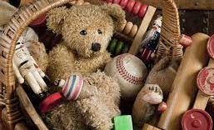

I need to know:
- To know what different materials toys are made of
- Toys are now made mostly from plastic
- Toys in the past were made from wood and metal
- Know what games people played in the past
- Know how different toys were used
- Know that there is more variety of toys today

Key Vocabulary | Definition
Victorian | The time of Queen Victoria’s reign. 1837-1901.
20th century | The 20th century was 1900-1999
21st century | We are in the 21st century. It started in the year 2000 and will end in 2099.
paper toys | Some toys, like paper windmills, were made out of paper.
metal toys | Toy soldiers and some spinning tops were made out of metal.
wooden toys | Toy soldiers and some spinning tops were made out of metal.
modern | Things made now or recently.
past | Objects and things that happened before now.
Plastic toys | Most modern toys are made of plastic. Toy soldiers, dolls and ride-on cars are usually made of plastic.
By the end of this topic, I will be able to:
- Identify different sources we can use to find out about the past.
- Ask and answer simple questions.
- Place different toys on a timeline
- Compare two toys from different time periods, identifying similarities and differences
- Suggest reasons for why toys have changed.

