Knowledge Organiser – Autumn 2023
Subject | Topic Title | Phase
History | Ancient Rome | Year 3/4

Key Vocabulary What do I need to know?
I need to know:
- When the Roman Empire existed
- Who Boudicca was and her influence on the Celtic tribes
- That Julius Caesar tried to conquer England and why
- When and how Emperor Claudius conquered England
- How the Romans lived – roads, homes, school, clothes
- About the gods and religious beliefs of the Romans
- How the Roman army was organised and what life was like for the soldiers
- What legacy the Romans left us

Key images / maps

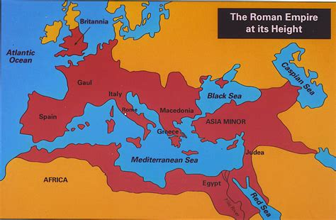

Key Vocabulary | Definition
Celts | People living in Britain in tribes, including the Iceni, Brigantes and Catuvellauni.
Citizen | A person with all the rights and protections of a nation or land. In the Roman Empire, only citizens were  able to vote.
Conquer | Taking control of a place by force, often with an army.
Emperor | The ruler of an empire.
Empire | A group of countries controlled by one ruler (emperor or empress) or government.
Legion | A large section of the Roman army, made  up of around 5000 soldiers.
Rebellion | An uprising or revolt by people who want to challenge what they believe is unfair treatment by rulers.
Roman Empire | The name used for the land that was controlled by the Romans, including large parts of Europe plus parts of North Africa and West Asia.
Tribe | A group of people who share the same culture and values.
By the end of this topic, I will be able to:
- Find and analyse a wide range of evidence about the past
- Identify key events and features of the Roman period
- Begin to evaluate the usefulness of different sources of evidence
- Place events from the Roman period on a timeline

Font (Twinkl cursive, 11 font, no bold for bullet points)

