Knowledge Organiser – Summer 2023
Subject | Topic Title | Phase
Geography / History | World War Two | Year 5/6

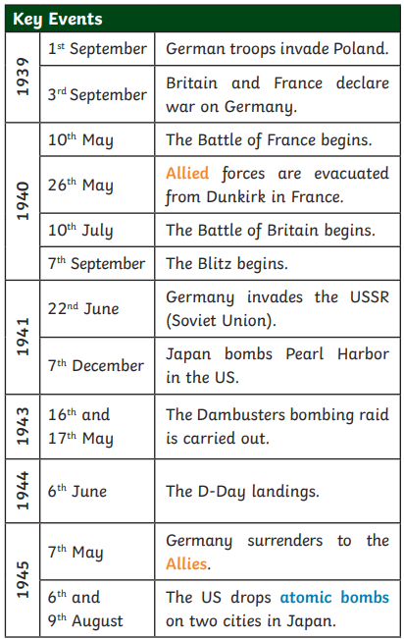
Key Vocabulary What do I need to know?
I need to know:
- That WW2 started on 1st September 1939, when Germany invaded Poland. Britain and France (Poland’s allies) gave Germany notice to withdraw their troops. When they did not, war was declared.
- That people expected cities to be bombed as the Germans tried to hit military or trade targets. This would put children in danger, so many were sent to live with families in the countryside until the war ended.
- That The Holocaust was a genocide committed by Germany before and during WW2. It involved the murder of over 6 million Jewish people and millions of others.
- Women played a huge role in war in the Home Front and ‘Digging for Victory’.
Key Vocabulary | Definition
Nazi  party | A German political party with  racist and anti-Jewish ideas, led  by Adolf Hitler.
Allies | The United Kingdom, France and  Poland, later joined by other  countries, including the USSR  (Soviet Union), the United States of  America and China.
Propaganda | Information designed to promote  a political idea or opinion.
Axis | The Axis Powers were originally  Germany, Japan and Italy. Other  countries joined them later.
Atomic  bomb | A very high-energy bomb made of  radioactive material.
Czechoslovakia | A European country. Now two  countries: the Czech Republic  and Slovakia.
Annex | To take another country’s land  and make it part of your country.
By the end of this topic, I will be able to:
- Understand the key people, dates and events that shaped World War II.
- Use appropriate historical terms such as culture, religious, social, economic and political when describing the past.
- Plot the key events of the war on a timeline alongside other events in history.
How did World War II start?
The leader of Germany, Adolf Hitler, had plans to take over other countries. In March 1938, Germany invaded and annexed Austria, which made other countries worried. On 29th September 1938, British, French, German and Italian leaders signed a treaty called the Munich Agreement. This allowed Hitler to annex the Sudetenland (an area of Czechoslovakia) if he agreed not to invade anywhere else. However, in August 1939, Hitler broke the agreement and invaded the rest of Czechoslovakia, followed by Poland on 1st September. Britain, France and Poland had made a pact to support each other, so Britain and France declared war on Germany.

