Behaviour Policy
November 2023

St Mary’s Catholic
Primary School
Bognor Regis
Introduction
At St. Mary’s Catholic Primary School, we aim to create a stable and happy environment for all our children where they can develop respect, care and tolerance for others whilst growing in self-confidence and a sense of their own worth.

The spiritual, moral and cultural, mental and physical development of every child is of great importance to all at St. Mary’s. We actively aim to prepare them for the opportunities, responsibilities and experiences of life by promoting good behaviour at all times. We hope that by our guidance and example our children will be encouraged to develop attitudes of caring, support and loving concern for others. We want the children to make
positive choices in their behaviour and have the confidence to turn away from wrong behaviour. We want them to do this for themselves, our school community and as a celebration of God’s love.

We understand that all behaviour is a form of communication. We value children’s voices and experience in all areas of school life and know that when we listen to them in the spirit of Gospel values, we can nurture their self-esteem, their relationships and their behaviour for learning.

We work with parents and members of the local community to encourage good behaviour following the example of Jesus Christ.

Our Behaviour Policy is rooted in our Mission Statement, and should be read in conjunction with our Teaching & Learning Policy, Anti-Bullying Policy and Use of Restraint Policy.
The Beatitudes, our code of behaviour, is displayed in all classrooms and in the entrance area. Staff regularly refer to it and explain it to the children according to their age/maturity.

Our Principles:
• We seek to provide an environment which is happy and safe, and secure in the love of Christ
• We value each member of the school community as unique with their own dignity given by God. We will respect their property and the environment they work in
• We do not accept bad behaviour which threatens the rights of others to learn, work and be happy
• We use sanctions constructively so that individuals recognise the natural consequences of their actions
• When we sanction we do not demean or degrade. We take account of the individual and the circumstances
• We acknowledge there are times when we need to say sorry, heal the hurt and forgive. We encourage our children to do the same
• We recognise the need to listen with compassion and generosity
• We will always encourage parents and pupils to work in partnership with us to move forwards positively

The Be-attitudes-Our School Code of Behaviour:
The School Council decided our code should be like the Beatitudes – attitudes we should try to be!
We will:
• Be kind – in what we do and say
• Be thoughtful – think about what we do and say
• Be polite – speak nicely to everyone
• Be supportive – help one another
• Be respectful – treat others as Jesus asks
• Be generous – give your time and help to others

Restorative Approach
We use a restorative approach to behaviour management

For real change to take place it is essential that the children face up to their own responsibilities in a realistic and reflective manner. We are giving pupils the skills to independently make better and more informed choices in the future and encouraging them to think about how their behaviour affects others, both pupils and staff. It helps children to develop respect, responsibility and truth telling. If a pupil in our school has been negatively affected by someone’s behaviour we will try our very best to make sure they feel that it has been put right for them and that it will not happen again. If a child has done something wrong they will be asked to put things right and change their behaviour so it does not happen again. This will take the form of ‘restorative conversations’ with all parties involved.

Effective restorative practitioners will:
- Use a wide range of skills and tools
- Respond to and understand the children’s emotional state, giving time for reflection
- Support children to recognise their emotions, self-regulate and use strategies to move positively within the Zones of Regulation (Appendix 1)
- Use restorative questions when dealing with any behaviour incidents (Appendix 2)
- Use relevant and agreed sanctions for poor choices of behaviour when necessary
- Manage their own emotions well, at all times modelling good emotional management to the children
- Remain calm and rational, remembering that their emotions will influence the classroom climate
- Build positive relationships
- Have high expectations
- Be consistent
- Show an interest in children as individuals
- Listen to the point of view of others
- Give children responsibility
- Treat others with respect

Playtimes and lunchtimes

Positive behaviour is reinforced at playtimes and lunchtimes by all adults who have been trained in restorative approaches and zones of regulation. We promote ‘active playtimes’ where staff are engaged talking and playing with the children.

Unacceptable behaviour

We want everyone to feel included, respected and safe in our school. We will not tolerate any behavior that discriminates in any way against any pupil, including discrimination against any of the protected characteristics.

Protected characteristics are those which discriminate based on age, disability, gender reassignment, marriage and civil partnership, pregnancy and maternity, race, religion and belief, sex, and sexual orientation.
This also includes behaviour or attitudes that create stereotypes of social roles based on the protected characteristics.

All staff and pupils are encouraged to challenge and report this behaviour. If pupils make these comments, we will:
- Support and educate them to improve their behaviour
- Ask them to apologise to anyone the comment was directed at
- Respond with an appropriate sanction.
- Inform both sets of parents/carers
- Monitor their behaviour for any recurrence

Our Relationships Sex and Health Education (RSHE) curriculum, Life to the Full by TenTen, will cover what healthy and respectful relationships look like. Please see the RSHE Policy on the school website. Parents have access to further information through the parent portal.
How we promote positive behaviour around the school

We encourage reciprocal, respectful behaviour and interactions between all members of the school community, including:
- All should encourage appropriate behaviour around the school
- All should be encouraged to walk in the corridors, and on the left on staircases
- All should use children’s names
- All should always say hello to children they meet outside the classroom
- All should make efforts to get to know the children as individuals
- All are responsible for behaviour of children around the school
- Adults should use ‘affective’ language, modelling positive behaviour, expectations and interaction
These actions should lead to self-regulation amongst the school community.

Use of Rewards and Sanctions

Rewards:

- We believe that positive feedback is the most effective reward – specific praise, smiles, thumbs up, thank you etc; this leads to intrinsic motivation
- Developing intrinsic motivation takes time. Extrinsic rewards (such as stickers, smiley faces, names on boards) are not effective in the long term but could be used as a quick win where appropriate. Children should be encouraged to self-regulate and to make the right choices
- House points will be given as a reward when children have exceeded expectations either for their work or behaviour. This encourages collective responsibility and feeling of community

Sanctions

- We use a graduated restorative approach to sanction appropriately where necessary.
- Sanctions should be a natural consequence* of the behaviour and help to restore relationships, help the child understand the impact of their actions and improve their future choices
- Warnings and consequences will be used consistently across the school (Appendix 3)
- Warnings and consequences can range from reflection time, conversation with SLT, phone call to parents/carers or loss of playtime, where this may help children to make better choices
- In certain cases a child may be directed to spend time in another classroom completing their work, where this may help children to make better choices

*Natural consequences are those that happen as a direct result of a choice or an action e.g. if a piece of work had been screwed up, a child would be asked to re-do the piece of work; if there has been a playtime incident and a child has been hurt, they may need to give some of their free time to write an apology.

Suspension

We are an inclusive school and will work hard to develop strategies to include all children, however, in the case of very serious incidents which fall outside the boundaries of acceptable behaviour, the Headteacher may exercise the right to suspend a child from school or their class. Such suspensions may be for a fixed period or permanent, following West Sussex guidelines.

Reporting behaviour incidents
- Any incidents should be reported to the class teacher
- It is the responsibility of all adults involved to record any behaviour incidents on CPOMS including details of the restorative process and any sanctions

In all cases it is the responsibility of the class teacher to maintain positive behaviour management in their classrooms.

Appendix 1

Zones of Regulation

What is it?
Zones of Regulation is a concept developed by an American teacher called Leah Kuypers. It integrates different well-known approaches into a curriculum that can be used for all pupils, providing them with knowledge and tools to develop social, emotional and sensory regulation.
Initially it was developed with neurodiverse pupils in mind as Leah had been working with children with ADHD and Autism and she regularly encountered times when the children were dysregulated but had few tools to be able to self-regulate. However, over time it has proven to be a beneficial curriculum for all pupils.

How is it useful?
Regulation is something everyone continually works on whether we are aware of it or not. We all encounter trying circumstances that can test our limits. If we can recognise when we are becoming less regulated, we are able to do something about it to manage our feelings and get ourselves to a healthy place. This comes more naturally for some, but for others it is a skill that needs more attention and practice. This is the goal of The Zones of Regulation​.

Feelings are complicated. They come in different sizes, intensities, and levels of energy that are unique within our brains and bodies. To make them easier to talk about, think about, and regulate, The Zones of Regulation organises our feelings, states of alertness, and energy levels into four coloured Zones – Blue, Green, Yellow, and Red.

The simple, common language and visual structure of The Zones of Regulation helps make the complex skill of regulation more concrete for learners and those who support them. We learn to regulate our Zones to meet our goals and task demands, as well as support our overall well-being.

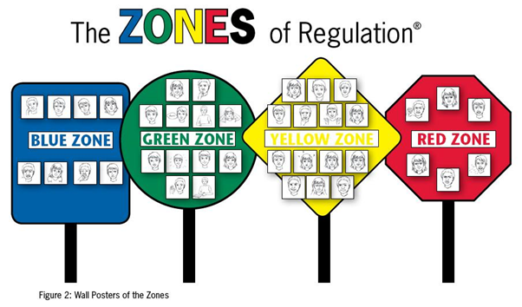

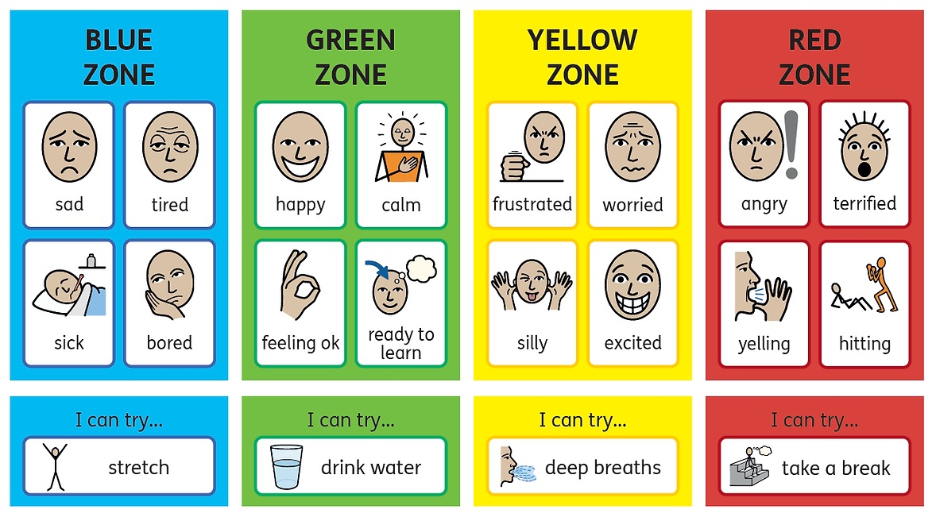

Appendix 2
Restorative Questions

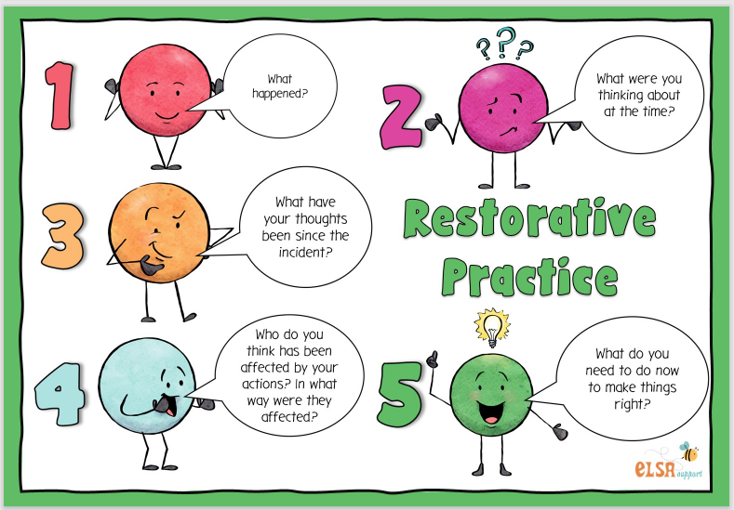
Appendix 3
Warnings and Consequences

WARNING CARD
De-escalation is key in a restorative approach: Use a calm voice and agreed questions to find out what happened. Allow thinking time. Offer choices and consequences.
Warning cards should never be used for EYFS – talk to Mrs Cole if there is an issue.
All incidents must be recorded on CPOMS under ‘behaviour’ and reported to the teacher.
If a Warning Card is ignored a consequence may be necessary.
Behaviour | Time out on the fence to calm down if needed  (5 mins only) | Response following restorative conversation
Swearing |  | Record incident.  Sincere apology
Pushing and shoving |  | Record incident.  Encourage a conversation between the children to move to a sincere apology and a resolution
Rough play/squabbling |  | Record incident.  Encourage a conversation between the children to move to an apology and a resolution. Reminder of the ‘no play-fighting’ rule
Friendship issues |  | Record incident.  Distraction/ ask child to help find a solution. Inform teacher if this is a persistent problem.
Constant unruly behaviour, rudeness, ignoring instructions. |  | Record incident.  Sit on another table away from friends/ consider moving to another sitting. Inform teacher if this is a persistent problem.

MMS DEALING WITH BEHAVIOUR

- All collect notebooks and house point tokens from AK at start of shift
- Place in bum bags
- Record the date, children involved, time, what happened and the consequence / sanction.
- Inform the adult in charge of the class
- At end of lunchtime, return notebooks and house point tokens to Amy.
- Amy to record incidents on CPOMS

CONSEQUENCE CARD
De-escalation is key in a restorative approach: Use a calm voice and agreed questions to find out what happened. Allow thinking time. Offer choices and consequences.
Consequence cards should never be used for EYFS – talk to Mrs Cole if there is an issue.
All incidents must be recorded on CPOMS under ‘behaviour’ and reported to the teacher.
Behaviour | Restorative approach:  Remove the child from the situation: Time out in thinking area followed by restorative conversation | Consequence following restorative conversation
Deliberate damage to school property |  | Record incident.  Teacher informed and adds an action. Internal suspension considered.  Teacher informs parents
Physically hurting another child (bites/scratches/punches) |  | Record incident.  Teacher adds an action. Internal or external suspension. Teacher informs parents
Racist/hate language used  Language or actions that discriminate against the protected characteristics. |  | Record incident/ call lunchtime duty teacher – Staff member involved adds to CPOMS and informs SLT immediately. SLT adds an action.  Suspension considered.
Unprovoked assault on staff member |  | Record incident/staff member involved adds to CPOMS. Call lunchtime duty teacher to remove child – and informs SLT immediately. SLT adds an action. Suspension considered.
Swearing aggressively |  | Record incident/staff member involved adds to CPOMS. Teacher informed. Teacher adds an action.– Teacher informs parents
Regular low-level poor behaviour and ignoring warnings |  | Come in from field / playground and wait next to House-point board near Hall.

MMS DEALING WITH BEHAVIOUR

- All collect notebooks and house point tokens from AK at start of shift
- Place in bum bags
- Record the date, children involved, time, what happened and the consequence / sanction.
- Inform the adult in charge of the class
- At end of lunchtime, return notebooks and house point tokens to Amy.
- Amy to record incidents on CPOMS

