Knowledge Organiser – Spring 1 2023
Subject | Topic Title | Phase
History | Lifeboats and Lighthouses | Year 1/2

Key Vocabulary What do I need to know?
Key images / maps

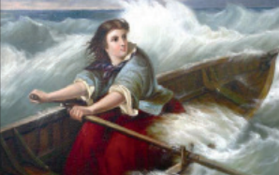

I need to know:
- Who was Grace Darling?
- What was Grace Darling’s everyday life like?
- What did Grace Darling do to make her famous?
- What can we learn from Grace Darling’s example?
- How has sea rescue improved as a result of Grace Darling’s story?
- What is it like to be a life guard today?

Font (Twinkl cursive, 11 font, no bold for bullet points)

Key Vocabulary | Definition
Lighthouse | A tower containing a light to warn or guide ships at sea
Lifeboat | A special boat launched from land to rescue people in distress at sea.
Rescue | To save someone from a difficult situation
Forfarshire | A paddle steamer ship built in 1834 to transport passengers and cargo between Hull and Dundee that crashed into rocks in 1837.
Victorian | The period of time during Queen Victoria’s reign.
RNLI | Royal National Lifeguard Institute.
Brave | To show courage in the face of danger.
Hero | Someone who is admired or celebrated for their courage.
Crew | A group of people who operate a ship.
By the end of this topic, I will be able to:
- Know some of the main events in Grace Darling’s life.
- Recount the story of the Forfarshire rescue.
- Use different sources to find out about the past including Grace Darling’s diary
- Make links between the heroism of Grace Darling and modern RNLI
- Describe RNLI rescue today and saw how it has changed.

Font (Twinkl cursive, 11 font, no bold for bullet points)

