Knowledge Organiser – Summer 2024
Subject | Topic Title | Phase
Geography | Oceans and Coasts | Year 1/2

Key Vocabulary What do I need to know?
I need to know:
- What is a coast line?
- What are some features found along the coast of Britain?
- What are cliffs and how do they differ?
- What is it like to live in a coastal area?
- What are harbours and ports?
- What are the 7 continents called?
- What are the names of the oceans?
- How do I locate different places on a map?

Key images / maps
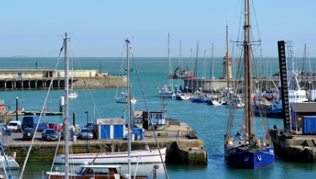
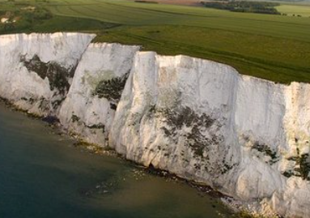

Key Vocabulary | Definition
Coast | Coast: the area where land meets ocean or sea.
Beach | Land that along the coast and is low to the sea made from sand or shingle.
Cliff | A steep rock face found along the coast.
Port | A port is an installation that has been built around a harbour with facilities for loading and unloading such vessels.
Harbour | A harbour is any sheltered body of water where boats or ships may moor or anchor.
Ocean | A large expanse of sea
Continent | The main masses of land in the world.
Compass | Someone who is admired or celebrated for their courage.
Jurassic Coast | A coastline in Britain that is known for having fossils in its rock.
By the end of this topic, I will be able to:
- Recognise different features found along the coastline of Britain, e.g. beaches, cliffs, seas, rivers etc.
- Explain what a beach is.
- Tell the difference between a port and a harbour.
- Use photographs to compare different coastal areas in Britain.
- Recognise the N, E, S and W.
- Use a map to locate the continents and Oceans.

