Knowledge Organiser – Summer 2024
Subject | Topic Title | Phase
Geography | The Rainforest | Year 3/4

Key Vocabulary What do I need to know?
I need to know:
- The human and physical geography of a region of South America.
- Aspects of physical geography, including; climate zones and biomes.
- How to locate rainforests on a map using knowledge of continents.
- I can identify the position and significance of latitude, longitude Equator, Northern Hemisphere, Southern Hemisphere, the Tropics of Cancer and Capricorn, Arctic and Antarctic Circle, the Prime/Greenwich Meridian and time zones.
- The different layers that make up a rainforest.
- How the rainforest has an impact on us and others around the world.

Key Vocabulary | Definition
Deforestation | The action of clearing a wide area of trees.
Climate | The weather conditions prevailing in an area in general or over a long period.
Biome | A large naturally occurring community of flora and fauna occupying a major habitat, e.g. forest or tundra.
Flora | The plants of a particular region or habitat.
Fauna | The animals of a particular region or habitat.
Tropics | The region of. Earth's surface that is closest to the Equator is called the tropics.
Equator | An imaginary line that is drawn around the middle of the Earth to divide it into the Northern and Southern Hemispheres.
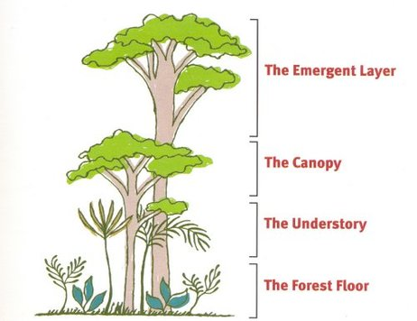
By the end of this topic, I will be able to:
- Compare a region of South America with our local area.
- Locate rainforests on a map.
- Describe the layers of a rainforest.
- Describe a location using key vocabulary.
- Identify the impact that the rainforest has on us.
Key images / maps

