Knowledge Organiser – Spring 2024
Subject | Topic Title | Phase
Geography | Earth Matters | Year 5/6

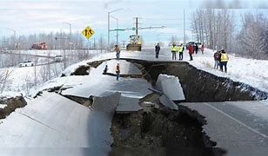
Key Vocabulary What do I need to know?
I need to know:
- The earth is made up of different layers including the crust and the core.
- That some countries are affected by earthquakes and the precautions people take when living in an earthquake zone.
- That earthquakes are measured and recorded using s seismograph.

By the end of this topic, I will be able to:
- Use maps to locate countries where earthquakes occur.
- Use appropriate vocabulary associated with earthquakes.
- Describe and understand the key aspects of an earthquake.
Key Vocabulary | Definition
Atmosphere | The envelope of gases surrounding the earth or another planet
Crust | The earth's crust is the thinnest layer of our planet, and it contains all known life in the universe
Upper Mantle | The upper mantle is a very thick layer of rock inside the Earth.
Lower Mantle | The lower mantle is the region 400 to 1,800 miles below the Earth's surface, made of solid rock.
Outer Core | The outer core is liquid iron and nickel and generates the Earth's magnetic field.
Inner Core | The inner core is the central part of the Earth's core.
Earthquake | A sudden violent shaking of the ground, typically causing great destruction, as a result of movements within the earth's crust or volcanic action.
Plate Tectonics | The Earth’s surface is called the crust. It is made up of different rocky sections called tectonic plates, which fit together like a puzzle covering earth.
Seismic Waves | Seismic waves are vibrating movement of the ground.
Epicentre | The point on the earth’s surface where the effects of an earthquake are felt most strongly.
Seismograph | An instrument that measures and records details of earthquakes, such as force and duration.
