Knowledge Organiser – Spring 2024
Subject | Topic Title | Phase
Science | Space (Y5) | Year 5/6

Key Vocabulary What do I need to know?
I need to know:
- The sun is the centre of our Solar System.
- The Solar System is a collection of planets, moons and the Sun.
- There are eight planets that orbit the Sun.
- The Sun is the largest object in the Solar System and has the greatest gravitational pull. This keeps all the planets in orbit around the Sun.
- The Earth rotates once around its axis in a 24 hour period. This is how we have day and night.
- Earth is the only known planet to support plant and animal life.
- The four seasons occur on planet Earth because the Earth’s axis is tilted.
Key images / maps

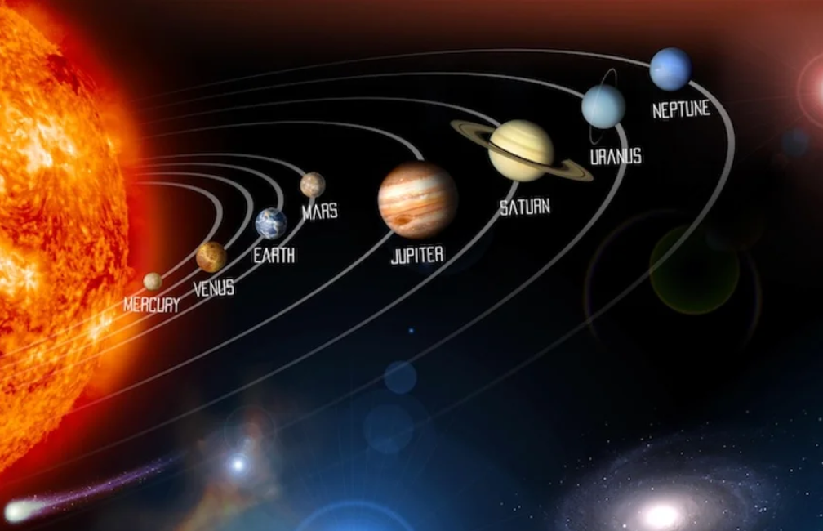

Key Vocabulary | Definition
Solar system | A collection of the eight planets and their moons, which orbit the Sun.
Planets | Large, natural objects that orbit stars, such as the Sun.
Stars | Large balls of burning gas that release heat and light.
Sun | The star at the centre of our solar system that releases heat and light.
Orbit | The path an object takes around another object, for example the Earth goes around the Sun.
Gravity | An invisible force that pulls things to the centre of the Earth.
Axis | An imaginary line that runs from the North pole to the South Pole. The earth’s axis is slightly tilted.
Rotation | The spinning of the Earth around its axis. The earth rotates once every 24 hours.
By the end of this topic, I will be able to:
- Show the planets in correct order from the Sun.
- Explain how the Earth rotates and revolves.
- Describe how the day and night, and seasonal changes occur.
- Identify the chemical and physical elements to sustain life on planets.

