Knowledge Organiser – Summer 2024
Subject | Topic Title | Phase
History | The Vikings | Year 5/6

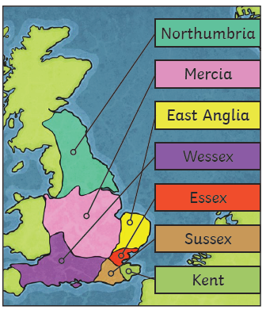
Key Vocabulary What do I need to know?
I need to know:
The Vikings came from the modern Scandinavian countries of Denmark, Norway and Sweden. They travelled in boats called longships and first arrived in Britain around AD 87.
The Vikings raided places such as monasteries and pillaged expensive items to trade. They were looking for valuable goods like gold and jewels, imported foods and other useful materials.
The Vikings also wanted to claim land and tried to take over much of Britain. They invaded and settled in Scotland before heading south to places such as York.
By AD 878 the Vikings had settled permanently in Britain. A local link involves King Canute landing in Bosham in the summer of 1015.

Key Vocabulary | Definition
Danegeld | “Paying the Dane”. King Etherlred paid the Vikings 4500kg of silver to go home but they kept returning and were paid 22,000kg of silver in Danegeld altogether.
exile | To be sent away.
kingdom | An area ruled by a king.
longship | A long, wooden, narrow boat used by the Vikings.
outlawed | Having all property taken away and no longer being able to live in the community.
pagans | A religion where many gods and goddesses are worshipped.
pillaged | To violently steal something.
raid | A surprise attack.
wergild | A payment system used to settle disputes between a criminal and the victim or their family.
By the end of this topic, I will be able to:
- Use maps to locate countries where the Vikings came from.
- Use appropriate vocabulary associated with the Vikings.
- Understand the daily life of the people in Britain 1,000 years ago.

