Literacy  Write a story about when your toys come to life. Think about ‘Toy Story’ for some ideas. What do your toys get up to when you are at school?  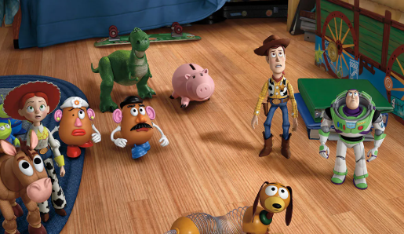 | Outdoors  What outdoor toys do you have? Ask someone to take a photograph of you playing with an outdoor toy or draw a picture of it. Can you write about what you do with that toy?  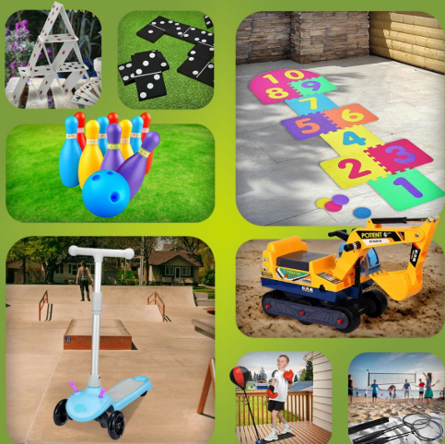 | Maths  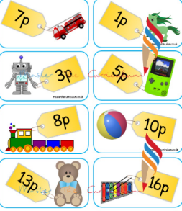  Set up your own toy shop at home! Give some of your toys price tags. Take turns to be the shop keeper and customer. Buy an item and find the correct coins needed to pay. Can you buy more than one item and use addition to find the total?
Art  Make your own puzzle Draw or paint a picture, then cut it up into 10 - 20 pieces. You have made your own puzzle! Bring it in for a friend to try.  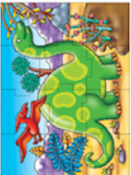 | In the Toy Box  Creative Homework  Please choose one to complete and bring to school week commencing Monday 3rd November. | Catholic Social Teaching  Have a look through your toys with a grownup. Are there any you haven’t played with for a long time? Could you donate any of these to a charity? Make sure you tell us about it if you choose to do this.  
History  Talk to a grandparent or an older relative or friend and find out what toys they played with when they were younger.  -What toys did they play with?  -What materials were they made from?  -Write down some of their answers and maybe even include a picture if you can.  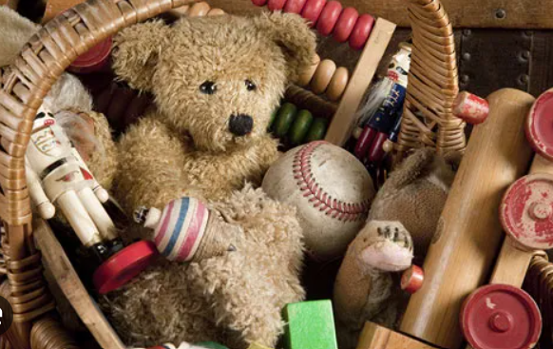 | Science/Maths  Sort your toys into groups. You can decide how you sort them, e.g. new and old or wheels and no wheels or which material they are made from. Take a photograph of your sorting or draw your results into a venn diagram.  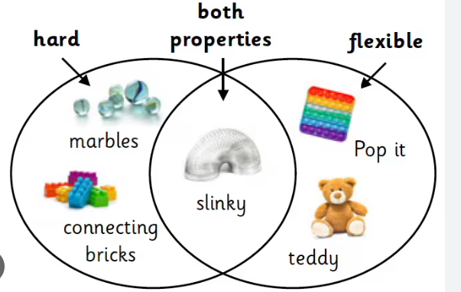 | DT  Make your own toy  Bonnie from Toy Story made Forky out of different materials? What toy could you make?  