CREATIVE HOMEWORK ACTIVITIES TERM: Autumn 2025
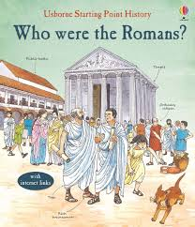
YEAR 3 and YEAR 4
Due in week beginning 03.11.25

Please pick ONE of the following activities to complete with your child.

The Romans left us some great ideas for food (did they eat pizza?)
Research and create an Ancient Roman dish to share with your class. (Please be aware that St. Mary’s is a nut free school! A list of ingredients used would be useful.)
The Romans did not have tablets or computer games. They enjoyed playing board games. With your family, research and create a Roman board game that can be played with your friends in class.
Research the life of a famous Roman such as Julius Caesar, Augustus, Claudius or Hadrian. Present your research in any form you choose for example PowerPoint, leaflet, poster, etc.
The Romans built some amazing buildings especially temples and stadiums. Build your own model of one of these buildings (- no bigger than a shoe box please!)

Use any of the ideas above to complete your homework task. Remember you can take pictures or be as creative as you would like to be.

