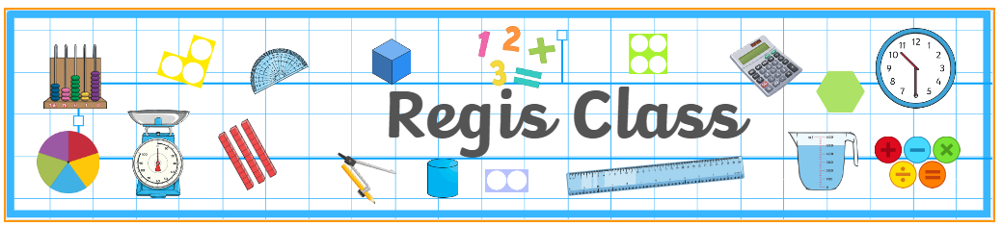

UKS2

**Welcome letter - Autumn Term 2025**

A warm welcome to this new year at St Mary’s. We are excited to begin this term in Year 5/6 having had some fantastic weather (is there such a thing as TOO hot?!), with many exciting challenges ahead. As a time of change for both our year 5s and our year 6s, and for us as teachers, we will be spending time with the children exploring what it means to be in Upper Key Stage 2 and becoming acclimatized to the new expectations that come with being at the very top end of the school.

Below you will see some key dates and information that you may find useful in the coming weeks and months.

|  |  |  |
| --- | --- | --- |
| **Regis Class** *– Mr Eyres* | **Hotham Class** *– Miss Howells* | **Wheatland Class** *– Mrs Edge* |
| **Supporting adults:** Mrs Smith  **PE days**: Mondays (outdoor) and Wednesdays (indoor).  **Assembly date**: Thursday 20th November at 8:40am  **Forest School:** Monday 29th September  **Mass:** Friday 14th November at 10am. | **Supporting adults:** Mrs Smith, Mrs Rex-Jones (am) and Mrs Turner (pm)  **PE days**: Tuesdays (outdoor) and Thursdays (indoor).  **Assembly date**: Thursday 6th November at 8:40am  **Forest School:** Monday 10th November and Monday 15th December.  **Mass:** Friday 26th September at 10am. | **Supporting adults:** Mrs Smith and Mrs Green  **PE days**: Tuesdays (outdoor) and Thursdays (indoor).  **Assembly date**: Thursday 27th November at 8:40am  **Forest School:** Monday 6th October  **Mass:** Friday 7th November at 10am. |
| **Whole School Mass:** Start of Term Mass at OLOS, 9am on Friday 12 September.  Harvest Festival at OLOS on Friday 3rd October at 2pm. | | |
| **Homework:** The homework we set will support the learning of the children this year and is an expectation that it is completed each week. Homework will be set on a Tuesday, and we will be checking and going through answers the following Tuesday.  *Year 5 expectations –* 10 games of TTRS, 10 games of EdShed spelling AND completed sentences in homework book along with written maths task.  *Year 6 expectations –* SATs Bootcamp will be up and running from the second week of term and the children are expected to complete each weekly maths and reading task. This will expose them to questions that they are likely to face in their SATs, ultimately making them less intimidating in May. They are also expected to write their weekly spelling into sentences in their homework books.  *Creative homework:* Please find ideas stuck into homework books related to our WW2 topic. | | |

* 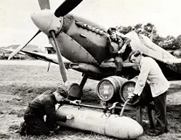

In our first term, we will be learning about World War Two, and this will include a trip to Fort Nelson on Tuesday 7th October. We aim to leave school at 9am and will return by 2:40pm. We would love to see as many parents and carers as possible on our topic sharing afternoon on Friday 12th December.  
  
Our main focus this term will be on books such as *Letters from a Lighthouse* by Emma Carroll and *Rose Blanche* by Ian McEwan, which have a variety of settings within World War Two. There are many other books, such as ‘Goodnight Mr Tom’, that help children immerse themselves in this topic. Please keep your children reading every day and ensure they keep their reading journals updated!

Please catch any of the UKS2 team on the playground to introduce yourself or bring any questions you have.

Kind regards, UKS2 team