Literacy  Create a fact file about one of the countries in the U.K. You could make a poster or a leaflet or even write facts and stick them onto a picture.  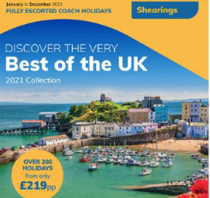 | Outdoors  Do you have a favourite place you like to go and visit? Where is it?  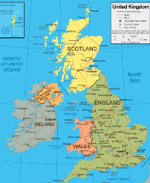  Could you write about this place or maybe even draw some pictures of it. You could bring in some photographs to share with your class. | Maths    Could you practice your measuring skills by following a recipe. Maybe you could make some shortbread (Scotland) or Welsh cakes (Wales). Make sure that you weigh your ingredients accurately.
Art  Could you paint/draw/collage a picture of a landscape in the United Kingdom. Maybe the London Skyline or the mountains in Wales.  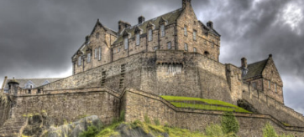 | Our island home  Creative Homework  Please bring to school week commencing Monday 23rd February. | Catholic Social Teaching  Think about how you could take care of our country and the town we live in. Do you know of any places or any things that we do in our town, school or at home to take care of our planet?  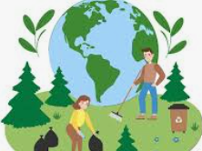
Geography  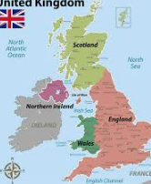  Make a map of the UK. You could use playdough, salt dough or draw, paint or collage.  Maybe you know somebody that lives in a different part of the UK – ask them some questions about what it is like to live there. | Science  What animals and plants live in the UK? Do all four countries have the same animals?  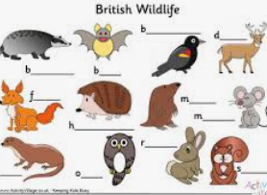 | DT  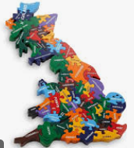  Make a jigsaw puzzle with no more than 10 pieces. You could either make a puzzle of a map or a landmark from one of the countries in the UK.

