
Knowledge Organiser – Spring Term 2026
Subject | Topic Title | Phase
Geography | Our Island Home | Year 1/2
I need to know:

- The difference between a continent and a country.
- That I live in England.
- That England, Scotland, Northern Ireland and Wales make up the United Kingdom.
- That the UK is an island.
- That the North Sea, Irish Sea, English Channel and the Atlantic Ocean surround the UK.
- The names of the capital cities of England, Wales, Scotland and Northern Ireland.
- The difference between human and physical features of Geography.
- The key characteristics of the four countries in the UK.

Key Images/maps
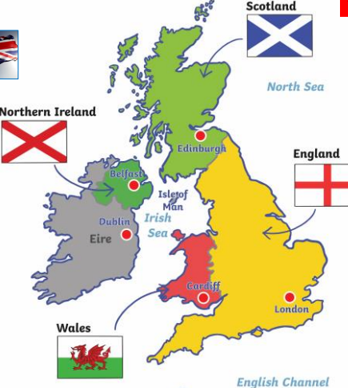
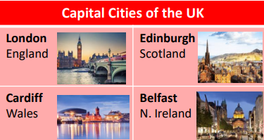
Key Vocabulary | Definition
Capital city | The city where the government is. London is the capital city of England.
City | The biggest settlement with lots of people, buildings, and things like hospitals and universities. It often has a cathedral.
Country | An area of land that has its own government.
Flag | A special piece of cloth with colours and patterns that are a symbol for a country.
Human features | Things that have been built by people, for example houses, roads, bridges
Island | A piece of land surrounded by water.
Landmark | Something that is seen or easily recognised from a distance.
Population | The number of people that live in an area.
Physical features | Things that are natural, for example rivers, seas, mountains, cliffs.
Settlement | A place where people live, work, and build their homes
Town | A place where many people live and work. It is smaller than a city with lots of houses, shops, schools, and often a town hall.
United Kingdom | The union of 4 countries on the British Isles – England, Scotland, Wales and Northern Ireland.
By the end of this topic, I will be able to:
- Identify my place in the world.
- Name and locate the four countries of the UK on a map.
- Name and locate the seas that surround the UK on a map.
- Name the capital cities of the countries in the UK.
- Show that I understand the difference between human and physical geography.
- Talk about some key physical and human features of the four countries in the UK.

