Dear Parents and Carers,
A very happy new year to you all and welcome to our Spring Term curriculum letter. The children have come back to school full of enthusiasm to learn and have enjoyed the start of our topic – Our Island Home. In this letter, you will find information to help you support your child’s learning and prepare them for what will be covered in the next term. We will be continuing our music lessons with Mr. Chalk on a Thursday afternoon, and we will now be learning the Ukelele.
Miss Stevenson and Miss Denton
Topic: Our Island Home  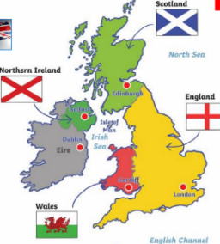  In this topic, children will be able to talk about their place in the world – they live on Planet Earth, in the continent of Europe, in the country England, which is in the United Kingdom. We will look at the four countries that make up the UK and their capital cities. We will also locate and name the seas that surround the UK. We will look at atlases and discuss what we see, learning to locate different places. When comparing the four countries of the UK, children will learn the difference between human features of geography, like houses, schools and roads, and physical features, like rivers, hills and beaches. By the end of the topic, children will be able to talk about some key landmarks in each of the countries.  Religious Education  We will continue our RE journey this half term with Branch 3 called Galilee to Jerusalem. This focuses on Jesus' ministry, teachings, parables, and miracles as He travelled from Galilee (his home region) to Jerusalem. In the second part of the term, we will continue our learning with Branch 4 Desert to Garden focusing on Lent, Holy Week and Easter. | Important Dates  Author Jim Beckett to visit KS1.  Tuesday 10th Feb  World book day (no fancy dress).  Thursday 5th March  Topic Sharing Afternoon  Tuesday 17th March 2:20- 2:40  Music Performance  Thursday 26th March 1:55 to 2:20

Homework
- There are going to be some changes made to homework this term. A separate letter will follow.
- It is so incredibly important that your child is reading at home. We ask that your child reads at least 4 times a week and that you record each read in their yellow reading journal.
- We love celebrating your child’s creative homework activities so please pick one to complete at home and ask your child to bring it in to share with us.
Physical Education
A reminder that Indoor PE is on a Monday and Outdoor PE is on a Wednesday.

Please make sure that your child has their PE kit in school The kit should include a St Mary’s PE top, royal blue shorts, and trainers. You may wish to include a navy-blue tracksuit (no leggings please) with a warm top for outdoor PE sessions, especially whilst the weather is cold.
Please note: Ear tape should be brought in to cover earrings please as many children have them.

