
Creativity Homework – Spring 2026 Regis, Wheatland & Hotham
Due 23rd February 2026
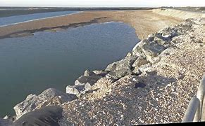 | 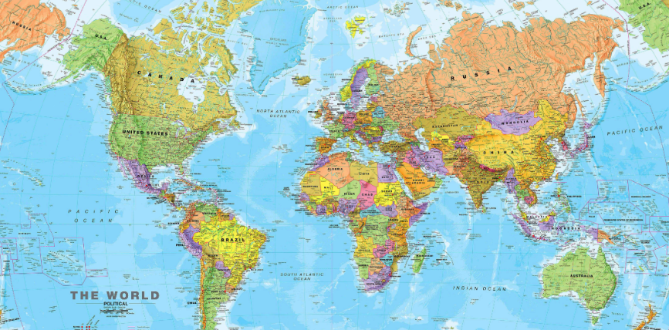 | 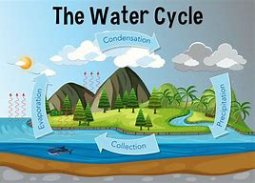
Visit Pagham beach or somewhere similar that has struggled with the effects of coastal erosion. Take pictures and/or talk to people about what has happened and what has been done to face this challenge. | Research a country that faces extreme weather conditions. You may want to create a fact file or something similar to present your ideas. | Research the Water Cycle and create your own one at home! You may want to create a poster to share your learning.
 |  | ?
Global warming is having a huge effect on the earth. Write a letter to explain global warming and persuade the people to help reduce the effects of global warming. Make sure you use effective language and techniques to be persuasive e.g. rhetorical questions | Create a collage/piece of artwork to show extreme weather conditions. | Create a PowerPoint presentation on how people use sources of power in their homes, school or in their work. Talk about how we can reduce or save our use of energy resources. Can you include some examples of renewable energy resources?

