
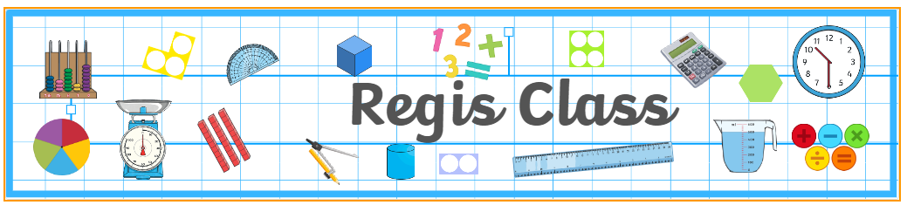
UKS2
Curriculum letter - Spring Term 2026
Welcome back and a very happy New Year. We hope you all enjoyed the Christmas break.
Below you will see some key dates and information that you may find useful in the coming weeks and months.
Regis Class – Mr Eyres | Hotham Class – Miss Howells | Wheatland Class – Mrs Edge
Supporting adults: Mrs Smith  PE days: Tuesdays (indoor) and Thursdays (outdoor).  Forest School: Monday 2nd February  Mass: Friday 6th February | Supporting adults: Mrs Smith, Mrs Rex-Jones (am) and Mrs Turner (pm), Miss Green  PE days: Tuesdays (outdoor) and Thursdays (indoor).  Forest School: Monday 2nd March  Mass: Friday 23rd January | Supporting adults: Mrs Smith and Mrs Green  PE days: Tuesdays (outdoor) and Thursdays (indoor).  Forest School: Mass: Monday 26th January  Mass: Friday 16th January
Whole School Mass: Start of Term Mass at OLOS, 10am on Friday 9th January.

Homework: The homework we set will support the learning of the children this year and is an expectation that it is completed each week. Homework will be set on a Tuesday, and we will be checking and going through answers the following Tuesday.
Year 5 expectations – 10 games of TTRS, 10 games of EdShed spelling AND completed sentences in homework book along with written maths task.
Year 6 expectations – SATs Bootcamp will be up and running from the second week of term and the children are expected to complete each weekly maths and reading task. This will expose them to questions that they are likely to face in their SATs, ultimately making them less intimidating in May. They are also expected to write their weekly spelling into sentences in their homework books.
Creative homework: Please find ideas stuck into homework books related to our ‘Earth Matters’ topic.


We will be learning about stewardship and physical geography through our topic, Earth Matters. This will include a trip to Bognor beach to understand
physical coastal changes. Further details to follow. We would love to see as many parents and carers as possible on our topic sharing afternoon on Tuesday 17th March from 2:40pm.
Our focus this term will be on the book, ‘Song of the Dolphin Boy’ by Elizabeth Laird which revolves around environmental activism, friendship, and the search for belonging. This will be followed by a poetry focus using the poem, ‘Peer Pressure’ by Karl Nova. There are many other books, such as ‘The Last Bear’ by Hannah Gold and ‘The Land of the Last Wildcat’ by Lui Sit, that help children immerse themselves in this topic. Please keep your children reading every day and ensure they keep their reading journals updated!
Please catch any of the UKS2 team on the playground should you need any questions you may have answered.
Kind regards, UKS2 team

