
Knowledge Organiser – Spring 2026
Subject | Topic Title | Phase
Geography | Earth Matters | Year 5/6

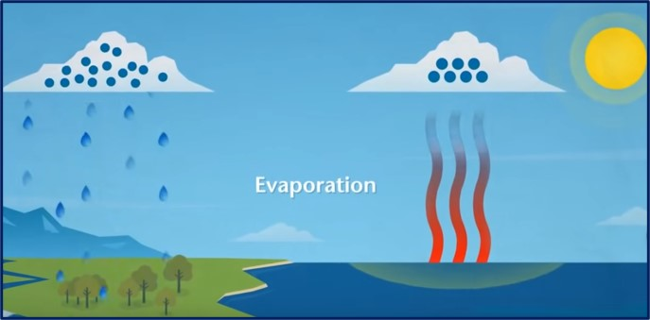
Key Vocabulary What do I need to know?
I need to know:
- Our coastlines are constantly changing; it is often slowly over time.
- To know that there are different ways to manage flooding such as building sea walls as a defence.
- To know that the water cycle consists of five main elements such as evaporation and condensation.
- To know that all rivers have a source (where they begin) and to locate this on a map.
- About our local rivers and coastlines and the effects that coastal erosion is having on people around us.

By the end of this topic, I will be able to:
- Understand the decisions made about how and where to defend the coastline.
- Understand and identify the features of the water cycle.
- Use maps to locate local features.
- Identify features of rivers and streams from source to sea.
Key Vocabulary | Definition
Flood Plains | An area of low-lying ground adjacent to a river, formed mainly of river sediments and subject to flooding.
Spit | A spit is a coastal landform of beach material that sticks out to sea and is joined to the mainland at one end.
Erosion | The process of eroding or being eroded by wind, water, or other natural agents:
Beach | A pebbly or sandy shore, especially by the sea between high- and low-water marks:
Cave | A natural underground chamber in a hillside or cliff.
Evaporation | The process of turning from liquid into vapour.
Condensation | Water, which collects as droplets on a cold surface when humid air is in contact with it.
Precipitation | Rain, snow, sleet, or hail that falls to or condenses on the ground
Collection | The action or process of collecting someone or something.
Arch | A coastal arch is a gate-like structure formed by the erosion of a headland by the sea.
Stacks | A coastal stack is a steep and often vertical column of rock in the sea near a coast, formed by wave erosion.
Lagoon | A stretch of salt water separated from the sea by a low sandbank or coral reef.
