Literacy  Can you make a travel brochure encouraging people to come and visit Bognor on holiday? Don’t forget to include all the lovely things that they can do in Bognor.  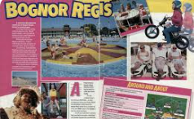 | History  What can you find out about Bognor in the past? It used to be a small fishing village before it became a good place for people to visit on holiday.  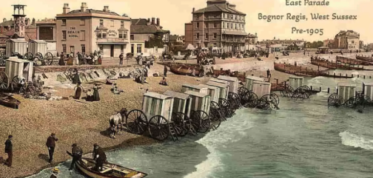 | Maths  Sit in a safe place with a grown up. Count the different vehicles (cars, buses, bikes) that you see . Record it using a tally chart, pictogram or bar graph.  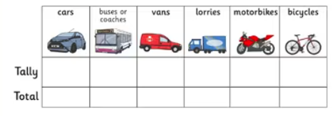  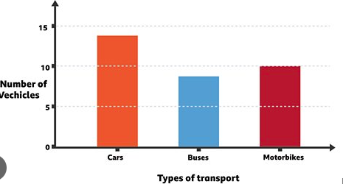
Art  Can you draw, paint or collage your favourite park, part of the beach or place to visit in Bognor Regis?  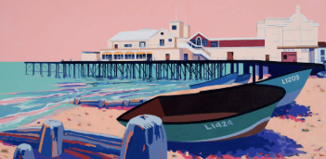 | Creative Homework - Summer Term 2026  No Place Like Home  Please bring one piece into school to share with us in the week after May half term. Week commencing 1st June 2026. | Catholic Social Teaching  Think about different ways that you could take care of our town.  
Geography  Design your own treasure map with a simple key.  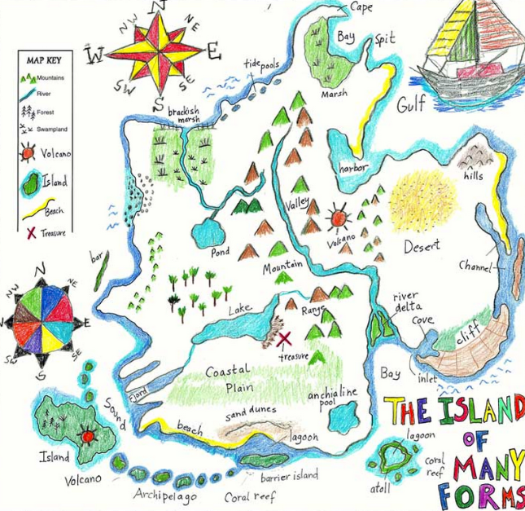 | Science  Identify two different local habitats in your local area. Go and visit them and draw/write what types of plants and animals you find there.  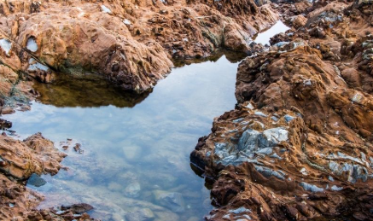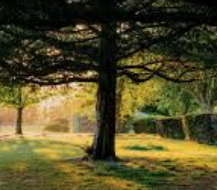 | DT  Can you design a new playground for Bognor? Try to include 5 different things You could draw and label your playground or even make it out of junk modelling.  