St Mary’s Catholic Primary School
Bognor Regis


Religious Education Policy

December 2025

Date of Approval by Governors
January 2026

To be reviewed in:
December 2027

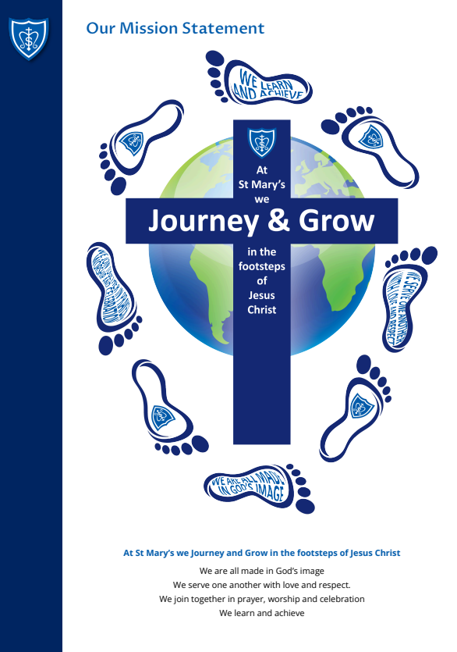

Introduction

This policy has been formulated with our school community in mind and by seeking advice and guidance from outside agencies including the Diocese of Arundel and Brighton Education Service, the Catholic Education Service and the Department for Education. The ideas and philosophies in Christ at the Centre (Stock 2013) and in the Catechism of the Catholic Church (CCC) have also helped to inform this policy.

The Importance of the Role of Parents in Religious Education

Our school community recognises the central role parents have in the religious education of their children. The Bishops’ Conference of England and Wales re-iterated in their statement on Religious Education in Catholic Schools (2000): “The first educators in the faith are parents.”

In recognition of this, we strive to maintain a faithful partnership with parents, communicating clearly both the curriculum and the wider spiritual opportunities offered to families and warmly inviting parents to share their knowledge and experiences with the school community.

Our school works closely in partnership with the home and Our Lady of Sorrows parish to which our children belong. The General Directory for Catechesis confirms, “This partnership between home and parish is enhanced by the role of the Catholic school in which the educational mission of the Church finds a particular and important expression.” Religious Education in a Catholic school encompasses the whole educational mission of the Church and is not confined to timetabled Religious Education lessons.

The Importance of Religious Education

Religious education is the "core of the core curriculum" in a Catholic school (Pope St John Paul II). Placing religious education at the core of the curriculum helps the school to fulfill its mission to educate the whole person in discerning the meaning of their existence

A Catholic education is “focused on integral formation of its students and at the same time prepares them for full participation in civic life. It forms the Catholic student as ‘both human and a person of faith, the protagonist of culture and the subject of religion’. It teaches subjects with methods proper to them and at the same time imbues the whole curriculum with a Christian outlook. It is established for Catholic students and at the same time draws others to its doors. In short, the Catholic school reflects the apparent paradox of the incarnation that is resolved in Christ: it is both fully Catholic and really a school. Religious education in a Catholic school also bears witness to the same mystery: it is both fully religious and genuinely educational.” (Religious Education Directory p9).
Our Aims for Religious Education
Religious education is at the heart of our school life. We aim to ensure that all pupils will have the opportunity to:
- Understand and live out our school mission statement
- Recognise and appreciate the religious and spiritual dimensions of life
- Develop a deeper knowledge and understanding of Catholic teaching and traditions and of the teaching of other religions, so that they can explain these ideas confidently
- Make links between learning in religious education and in the wider curriculum
- Take the space to reflect and ask questions about their own and others’ experience of life
- Deepen their personal faith commitment and respect the world views of others
- Develop a sense of love and responsibility for themselves, one another and the world around them, so that they can respond to this understanding in daily life (Catholic Social Teaching)
The Curriculum
At St Mary’s Catholic Primary School, religious education is primarily based on the Religious Education Directory (RED) “To Know You More Clearly”. In line with the Bishop’s mandate, the RE curriculum is taught through the Diosesan Day by Day resources.
In recognition of the importance of religious education in our school, we devote 10% of the teaching week to religious education lessons. In Key Stage 1 this is 2 hours 15 minutes and in Key Stage 2 this is 2 hours and 30 minutes, not including Collective Worship. In Early Years, the timetable and learning style is more flexible, but teaching of Religious Education is prioritised to give children the opportunity to engage fully with the curriculum.
The Religious Education Curriculum Directory has a clear framework for learning:
Four Knowledge Lenses: Hear, Believe, Live and Celebrate indicate what should be known by the end of each age phase.
Ways of Knowing: Understand, Discern and Respond are the skills through which children progress and develop their thinking during the curriculum journey.
Expected Outcomes set out for each year group what pupils should be able to know, remember and do.
Curriculum Branches divide the model curriculum into half-term units of study which repeat annually, giving a spiral curriculum which allows children to build progressively on the prior knowledge and develop their understanding year by year.
The curriculum branches are:
Autumn 1 | Creation and Covenant
Autumn 2 | Prophecy and Promise
Spring 1 | Galilee to Jerusalem
Spring 2 | Desert to Garden
Summer 1 | To the Ends of the Earth
Summer 2 | Dialogue and Encounter
The curriculum is firmly founded on building children’s knowledge and understanding of Scripture, while providing opportunities to make connections to other faiths and cultures, as well as to their daily lives.

RE in the classroom and beyond
At St Mary’s Catholic Primary School, the teaching of religious education is designed to be as varied and creative as possible, to help children to engage fully with the ideas explored, to ask wondering questions and to lead their own learning in discerning their response.
Learning within the classroom may include:
- Whole class discussion and teaching
- Group discussion and feedback
- Drama and role play
- Independent research
- Exploration through music and art
- Godly Play
- External speakers / workshops
Learning in religious education cannot always be recorded and does not begin or end in the classroom. Learning from religious education will also flow into other curriculum areas as pupils make links between their learning. We aim to give children the opportunity to connect their formal learning with their wider understanding through regular opportunities to reflect and respond.
Learning beyond the classroom may include:
- Following the example of a role model in daily life at home or in school
- Participation in charitable activity and fundraising
- Inspiration through reflection in prayer and liturgy
- Conversations with clergy or parishioners in school
- Response to catechesis in the parish e.g for Reconciliation or First Holy Communion
- Engagement with programmes based on Catholic social teaching e.g. Mini-Vinnies; Oscar Romero Award
We work closely with parents and with the parish to support children’s progress in understanding and developing on their curriculum and faith journey.
Other World Views
Catholic education seeks to form pupils who are well prepared to play a positive role in society and to follow Jesus’ teaching to “love your neighbour”. We therefore embrace learning about other world views with “a willingness… to try to understand better the religion of one’s neighbours, and to experience something of their religious life and culture.” (Catholic Bishops' Conference of England and Wales)

The Religious Education Directory includes a branch called ‘Dialogue and Encounter’ which focuses specifically on exploring other world views and recognizing the connections with the Catholic faith. Opportunities for dialogue and encounter are sought throughout the academic year and especially focus on broadening pupils’ experiences and on real-life encounters with those of other faiths or none, to enable connections and develop understanding. Examples may include:
- Opportunities for families in our community to share their faith and experience
- Conversations with invited visitors about their beliefs and experiences
- Q&A with faith leaders online or in person
- Visits to places of worship
- Guided exploration of artefacts from other faiths
- Independent reading, research and discussion
External speakers are always checked in line with the CES checklist for external speakers, to ensure safe and constructive dialogue and encounter opportunities for our pupils. External Speaker Checklist
Feedback, Assessment, Recording and Reporting
Developmental feedback is given in Religious Education to support children’s progress and to challenge their thinking. This follows the school’s Feedback Policy and may be given verbally.
Assessment follows diocesan and national guidelines, assessing against the expected outcomes for each branch in the Religious Education Directory. Pupil attainment is recorded half-termly on the school’s assessment recording system and progress is tracked regularly by the RE Lead and SLT in line with the school’s Assessment Policy.
The RE Lead moderates outcomes in Religious Education both internally and with local Catholic schools, to ensure consistency of expectations with other schools in the diocese. All teaching staff moderate annually with Deanery staff.
Outcomes for Religious Education are shared in line with other core curriculum subjects, both during parent consultation meetings and in end-of-year reports.
Monitoring and Evaluating
RE Leaders and SLT monitor every aspect of Religious Education in line with other core curriculum subjects. Monitoring is conducted at least termly in learning walks or drop-ins, and more formally at least annually with written feedback given to individual staff. Outcomes may inform further training at staff meetings or actions for the subject action plan.
Self-evaluation of Religious Education is the responsibility of the Head of School/RE Lead, Governors and the Senior Leadership Team, with further input from all teachers of religious education, from families and from pupils. This process ensures a culture of continuous improvement, so that teaching and learning in Religious Education remains the best it can be.

Staff Formation
All staff support the Catholic ethos of our school and strive to develop children’s progress and understanding in matters of faith. There are regular opportunities for all staff to engage in personal prayer and reflection which may support their professional role.
All teachers involved in planning and delivering Religious Education lessons have either attended half-termly diocesan training on the curriculum directory resources, or has had the training shared by a member of the team who has attended the training. The RE Lead collaborates with other local schools to share best practice more widely, and attends Diocesan training for RE Leads.

