Dear Parents and Carers,
We hope you had a restful Easter break and were able to enjoy the lovely sunshine. It’s hard to believe we are now beginning the final term of the school year! As always, we have a range of exciting activities and events planned for the coming weeks so please see below for key dates. This term also brings an important focus on supporting your children as they prepare for their transition into the next year group.
Thank you, as ever, for your continued support. Mrs Coulter and Mrs Matthews
Topic  This term, we will be exploring two exciting topics.  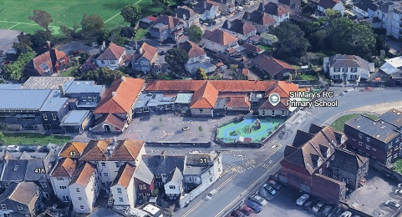  In the first half of the Summer Term, our topic will be No Place Like Home, where we will focus on our local area. The children will develop their geographical skills by learning how to use maps and compasses, as well as taking part in fieldwork within the local environment.    In the second half of the term, our learning will centre around a Beach theme. We will begin by learning about Grace Darling and why she is remembered today, before moving on to explore the important work of the Lifeboat service. As part of this topic, we will also study our own beach environment, including a visit to the beach.  Religious Education  This term we will cover two topics, the first being ‘To the Ends of the Earth’ which teaches about Jesus’ Ascension into Heaven, Pentecost and the journey His apostles took to spread the word.      The final topic of the year is called ‘Dialogue and Encounter’. Through these lessons, we will learn more about a different faith. | Important Dates  Forest School  Monday 27th April  Class Liturgy  Tuesday 16th June  Sports Day  Thursday 25th June  Transition Day  Wednesday 1st July  Topic Sharing Afternoon-  Tuesday 7th July, 2.30-2.50pm  Music Performance  Thursday 2nd July

Homework

Thank you for all your support with the new approach to homework. It has been brilliant to see the children’s enthusiasm for their new homework books!
- REMINDER: It is so incredibly important that your child is reading at home. We ask that your child reads at least 4 times a week and that you record each read in their yellow reading journal.

- We love celebrating the children’s creativity through their homework, so please encourage your child to choose one activity to complete at home and bring it in to share with the class.
Physical Education
Reminder that if your child wears earrings then they must have ear tape with them.
Outdoor PE is on a Wednesday and Indoor PE is on a Friday. Please make sure that your child has their PE kit in school.

