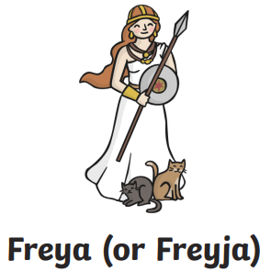 | 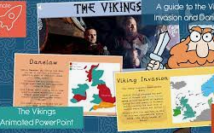 | 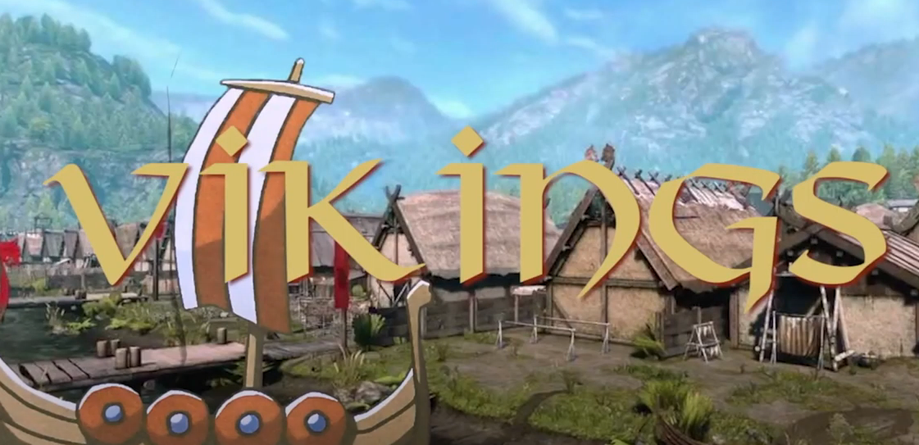
Design a set of Viking god top trump cards. Show your understanding of the different Viking beliefs by rating each god on different features. | Design a PowerPoint about a specific area of the Vikings such as their food, their home life, the clothes they wore or about the Viking invasions. | Create a Stop Motion animation linked to the Vikings. We’ve spent time in previous years learning how to use it – here’s some inspiration. – this video could provide some inspiration…  (https://www.youtube.com/watch?v=ctHxp2dbNN4)
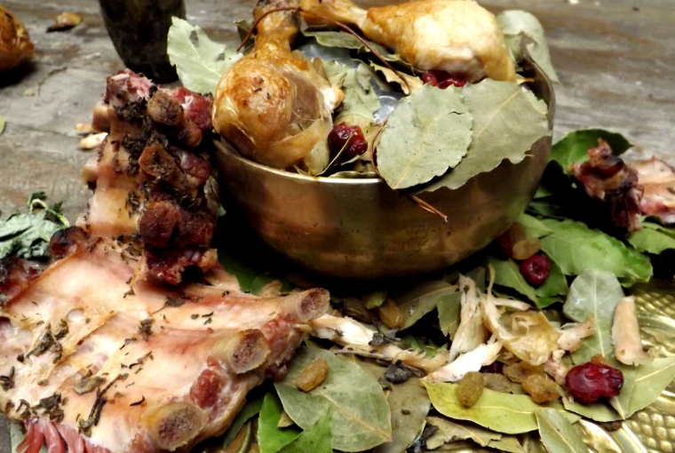 | 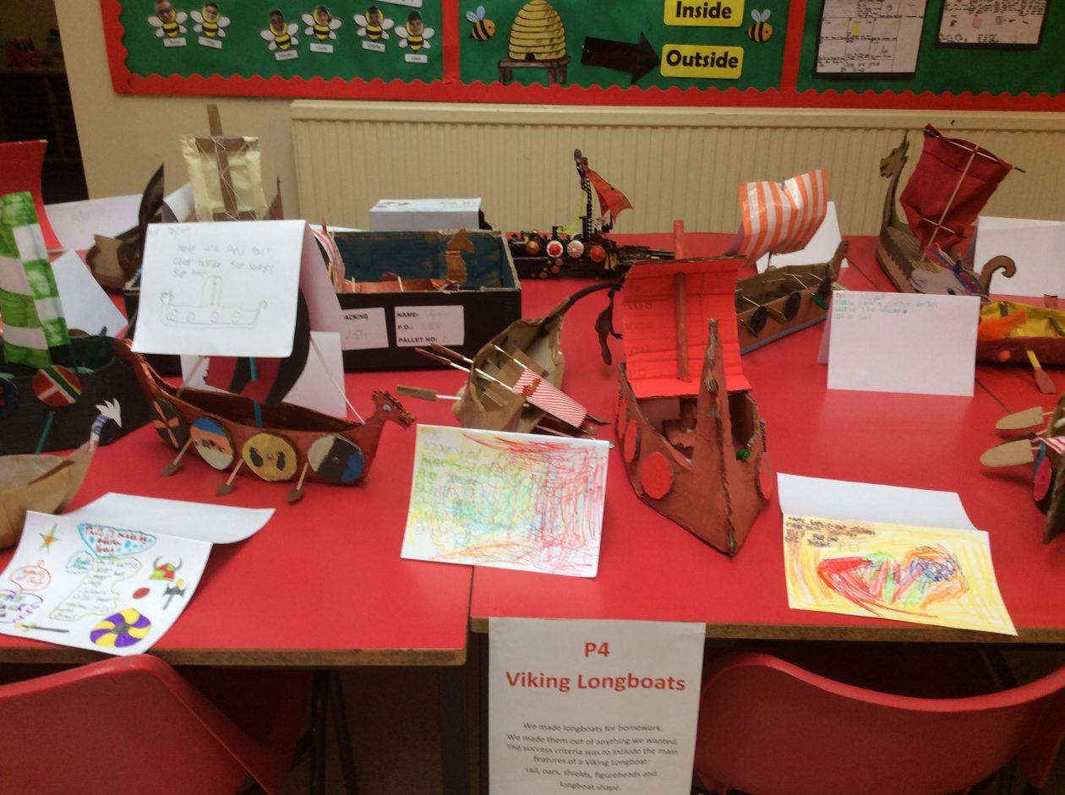 | 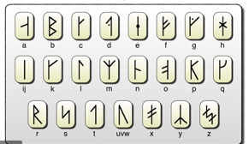
Create a Viking feast to eat with your family. Write a menu and take photos, explaining what you did and what you liked and disliked about their food. There are lots of ideas online. | Design a model of something traditionally Viking. Think creatively! Take photos of the design and making process, and write a set of instructions for someone else to use! | Use Viking runes to write a set of puzzles or challenges for someone else to solve. Research them online and present your work.  OR DO SOMETHING COMPLETELY DIFFERENT!
Due in from Monday 1st June 2026

