
UKS2
Curriculum letter – Summer Term 2026
Welcome back! We hope you all enjoyed the Easter break.
Below you will see some key dates and information that you may find useful in the coming weeks and months.
Regis Class – Mr Eyres | Hotham Class – Miss Howells/Mr Taylor | Wheatland Class – Mrs Edge
PE days: Tuesdays (indoor) and Thursdays (outdoor).  Forest School: Monday 18th May  Mass: Friday 5th June  Class Liturgy: Thursday 23rd April | PE days: Tuesdays (outdoor) and Thursdays (indoor).  Forest School: Monday 20th April  Mass: Friday 5th June  Class Liturgy: Thursday 7th May | PE days: Tuesdays (outdoor) and Thursdays (indoor).  Forest School: Monday 11th May  Mass: Friday 12th June  Class Liturgy: Thursday 30th April
Whole School Mass: Start of Term Mass at OLOS, 9am on Friday 24th April.
Sports day: Tuesday 30th June 1:15pm-2:45pm
Summer Fair: Friday 3rd July
Homework: The homework we set will support the learning of the children this year and is an expectation that it is completed each week. Homework will be set on a Tuesday, and we will be checking and going through answers the following Tuesday.
Year 5 expectations – 10 games of TTRS, 10 games of EdShed spelling AND completed sentences in homework book along with written maths task.
Year 6 expectations – SATs Bootcamp will be up and running from the second week of term and the children are expected to complete each weekly maths and reading task. This will expose them to questions that they are likely to face in their SATs, ultimately making them less intimidating in May. They are also expected to write their weekly spelling into sentences in their homework books.
Creative homework: Please find ideas stuck into homework books related to our ‘Earth Matters’ topic.
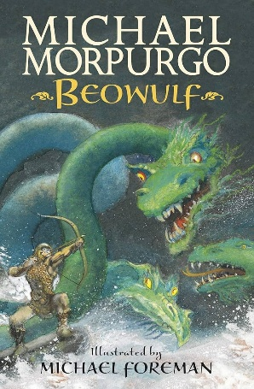
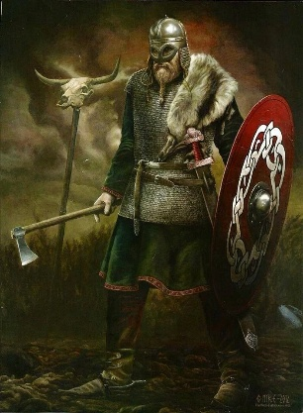
We will be learning about the Vikings and their invasion of Britain. This will start with a visit from a Viking in school to provide answers to many of the children’s questions on Thursday 23rd April. Please see the knowledge organiser for more details about what will be covering in our topic.
Our focus this term will be on the book, ‘Beowulf ‘, retold by many authors including Michael Morpurgo. This Old English story follows a Geatish hero who defeats three monsters: Grendel, Grendel's mother, and a fire-breathing dragon. There are many other books, such as ‘Viking Boy’ by Tony Bradman and ‘The Legend of Viking Thunder’ by M.G Leonard & Manuel Sumberac, that help children immerse themselves in this topic. Please keep your children reading every day and ensure they keep their reading journals updated!
Please catch any of the UKS2 team on the playground should you need any questions you may have answered.
Kind regards,
UKS2 team

