
Knowledge Organiser – Autumn Term 2026
Subject | Topic Title | Phase
History | Fire Fire! | Year 1/2
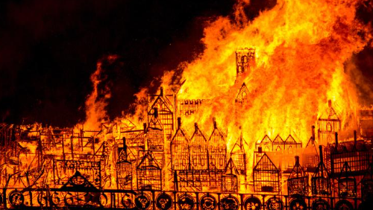
I need to know:

- The past is a time that has already happened.
- The present is the time that is happening now.
- That some things are the same and that some things are different between life in the past and life now.
- What beyond living memory means.
- That we remember some events in history because they changed people’s lives.
- We can ask questions to help us learn about history.
- Why it is important to put events in chronological order.

Key Vocabulary | Definition
17th century | From the year 1601 to 1700. The Great Fire of London happened in the 17th Century in 1666.
artefact | An object from the past.
chronological | Things that have happened in time order.
destroyed | When something can no longer be used.
evidence | Clues that help us learn about history.
eye-witness | A person who has seen something happen.
flammable | When something burns easily.
history | The study of things that have happened in the past.
London | The capital city of England.
past | The time that has already gone.
present | The time that is happening now.
re-build | Building something again after it has been broken or destroyed.
River Thames | The main river running through London.
timeline | Uses pictures and words to show the order of events.
source | something that gives us information about an event, place or person from the past
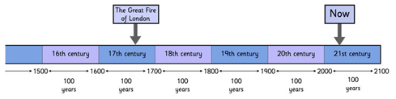
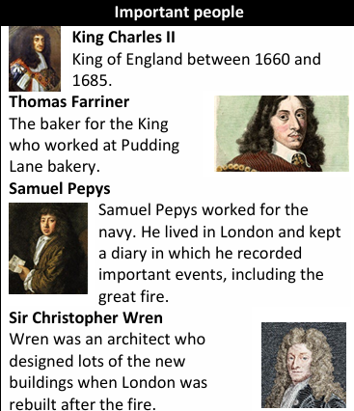
By the end of this topic, I will be able to:
- Explain where and when the Great Fire of London started.
- Understand why the Great Fire spread so quickly.
- Understand and talk about the order of events of the Great Fire of London.
- •Describe how London changed after the fire.
- To know why the Great Fire of London is still remembered today.
- •Have used different sources to find out about the Great Fire of London.

