
Knowledge Organiser – Autumn 2026
Subject | Topic Title | Phase
Geography | Awesome Earth | Year 3/4

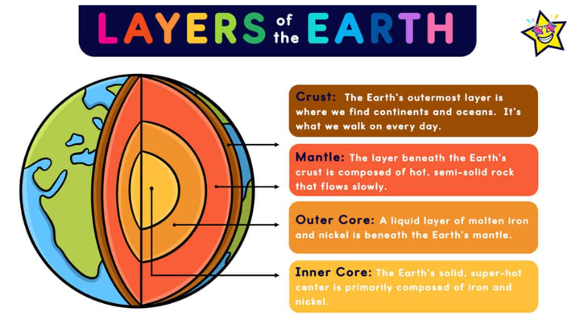
Key Vocabulary What do I need to know?
I need to know:
- Names of main countries and cities in the United Kingdom
- Geographical similarities and differences of human geography of a region of the UK.
- Physical geography, including; volcanoes, tornadoes, tsunamis, earthquakes.
- Human geography, including; types of settlement and land use.
- The location of hills, mountains, rivers and seas in the UK.
- How land height is shown on maps.
- How volcanoes are formed.
- How volcanoes affect human life.
- The causes and effects of volcanoes.

Key Vocabulary | Definition
physical features | things you can see around that are made by God.
human features | things you can see around that are made by humans
active volcano | a volcano that has erupted in the last 10,000 years.
dormant volcano | a volcano that hasn’t erupted in the last 10,000 years but may erupt again.
extinct volcano | a volcano that hasn’t erupted in the last 10,000 years but isn’t expected to erupt again.
outer core | liquid layer surrounding the inner core
inner core | solid iron layer at the centre of the Earth
mantle | the largest of Earth’s layers lying between the crust and the outer core.
tectonic plates | moving pieces of the Earth’s outer layer.
crust | the Earth’s hard outer layer made of different types of rocks.
magma | hot, liquefied rock
By the end of this topic, I will be able to:
- Identify similarities and differences of human and physical characteristics of regions within the UK.
- Explain the difference between a country, a county and a city.
- Locate mountains and rivers using an atlas.
- Use key language to describe location and position within my work.
- Describe how mountains and volcanoes are formed and the impact they have on our world.
- Describe other awesome events that take place in our world.

