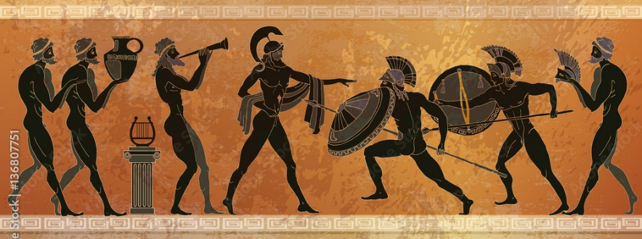
UKS2
A warm welcome to this new year at St Mary’s. We are excited to begin this term in Regis Class having had some fantastic weather (is there such a thing as TOO hot?!), with many exciting challenges ahead. As a time of change for both our year 5s and our year 6s, and for us as teachers, we will be spending time with the children exploring what it means to be in Upper Key Stage 2 and becoming acclimatised to the new expectations that come with being at the very top end of the school.
Regis Class – Mr Eyres | Hotham Class – Mrs Flaxbeard | Wheatland Class – Mr Taylor
Supporting adults: Mrs Smith  PE days: Tuesdays (indoor) and Thursdays (outdoor).  Forest School: Monday 16th November | Supporting adults: Mrs Smith and Mrs Green  PE days: Tuesdays (outdoor) and Thursdays (indoor).  Forest School: Monday 21st September & Monday 30th November | Supporting adults: Mrs Smith  PE days: Tuesdays (outdoor) and Thursdays (indoor).  Forest School: Monday 5th October
Whole School Mass: Start of Term Mass at OLOS, 9am on Tuesday 15th September
Homework: The homework we set will support the learning of the children this year and is an expectation that it is completed each week. Homework will be set on a Tuesday, and we will be checking and going through answers the following Tuesday. ALL children are expected to show that they have read, or read to, an adult in their yellow reading journals at least 3 times a week.
Year 5 expectations – 10 games of TTRS, 10 spellings given each week to be written into complete sentences in homework book.
Year 6 expectations – SATs Bootcamp will be up and running from the second week of term and the children are expected to complete each weekly maths and reading task. This will expose them to questions that they are likely to face in their SATs, ultimately making them less intimidating in May. They are also expected to write their weekly spelling into sentences in their homework books.
Creative homework: Please find ideas stuck into homework books related to our ‘Earth Matters’ topic.

- This term we will be learning about Ancient Greece – learning all about democracy, Greek myths and legends, gods and goddesses and daily life. Look out for dates for our end of term topic sharing.

- In theme with our Topic, we will be reading ‘Percy Jackson – The Lightening Thief’ as our class book – please feel free to bring in a copy should you have one.
- A reminder that children should have the appropriate kit for PE days. We will send these home to be washed frequently. Please ensure they are returned ready for your child’s next lesson.
As the children are now in UKS2 it is expected that they become more independent, that they are responsible for having the correct kit on the correct days; that they complete their homework to a high quality and ensure they bring it in on the correct day. This is in order to get them prepared for secondary school.
Kind regards,
UKS2 Team

