
Knowledge Organiser – Autumn 2026
Subject | Topic Title | Phase
History | Legacy – Ancient Greece | Year 5/6

Key Vocabulary What do I need to know?
By the end of this topic, I will be able to:
- Compare the beliefs and behaviour of the Ancient Greeks with another time studied (Romans, Egyptians etc.)
- Use appropriate historical terms such as culture, religious, social, economic and political when describing the past.
- Use a wide range of different sources to collect evidence about the past, such as ceramics, pictures, documents, printed sources, posters, online material, photographs, artefacts, sculptures and historic sites.
I need to know:
- Where Ancient Greece and other ancient civilizations come on a timeline.
- The importance of democracy and its origins.
- The names and roles of the Ancient Greek gods and goddesses.
- The basis of Greek mythology.
- Daily life for Ancient Greeks at different levels of society.
- The important legacies left by the Ancient Greeks – the Olympics, debates, democracy, the alphabet, government.
- Compare Ancient Greece with other ancient civilizations
Key Vocabulary | Definition
democracy
  A system where the citizens of a country or state are involved in the way it is run.
ancient | Something from a very long time ago.
civilisation | A human society with well-developed rules and government, often where technology and the arts are considered important.
empire | A group of countries or states that are ruled by one ruler or country.
legacies | Things that exist after someone dies or after a civilisation or event ends
myth | A story from ancient times about something that happened long ago that some people believed to be true.
primary source | Information and objects that come from the time being studied.
secondary source | Interpretations of information and objects which are produced after the time being studied.
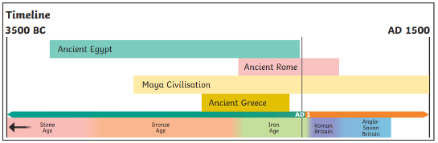
Key images / maps
